Prj381: Description of modeling script and ietraions

Kenneth Mc Ferrier 577503

Leon Botha 576378

Kealeboga Molefe 577482

Keneilwe Mpho Ramatsui 577669

Kaylee Carstens 577331

Contents

Criterion 1: Knowledge of the Problem Domain 3

Initial Data Preparation: 3

Download and organizing script: 3

The libraries we used for this script: 3

Steps in script: 5

Split Data Script: 6

The libraries we used for this script: 6

Steps in this script: 7

What the different sets get used for: 7

Initial Preprocessing Script: 8

The libraries we used for this script: 8

Steps in this script: 9

Criterion 2: Handling Complexities and Uncertainties 10

Second Iteration of the Model Training Script: 11

Different changes: 13

Results of the 2nd iteration: 15

Third Iteration of the Model Training Script: 16

Different changes: 17

Results of the 3rd iteration: 18

Fourth Iteration: 18

2nd Iteration of the Preprocessing Script: 18

Different changes: 19

**Results of the 4th iteration:** 20

Final Model Training and Preprocessing Scripts: 21

Model training script: 22

Preprocessing script: 24

Criterion 3: Application of Specialized Skills 25

Initial Model training script: 25

The libraries we used for this script: 25

Steps in this script: 26

Criterion 4: Ethical Considerations 28

Criterion 5: Information Presentation and Communication 28

Criterion 6: Understanding of System Interactions 28

Criterion 7: Accountability and Responsibility 29

UI Design: 29

Home page: 29

Project Charter: 29

Aim: 30

Project Suite: 30

Objectives: 31

Stakeholders: 31

Image processing: 32

Server startup: 32

Image upload: 33

Image processing: 33

# Criterion 1: Knowledge of the Problem Domain

* **Understanding of the Problem Domain:** The project aims to develop a machine learning model to classify plant life stages (flower, bud, etc.) based on images of floating plants. This task is significant for environmental monitoring, especially for managing the spread of invasive plants.
* **Relevance of Methodologies and Techniques:** The team applied transfer learning using the EfficientNetB0 model to leverage pre-trained features, supporting faster and more effective learning.
* **Solution Addressing Core Issues:** By iteratively improving the data preprocessing and augmentation techniques, the team addressed core issues of model accuracy, gradually increasing it from 23% to 56%.

# Initial Data Preparation:

## Download and organizing script:

The main goal of this script is to download and organize the images into the appropriate folders.

**(This script stayed the same throughout our model building process.)**

### The libraries we used for this script:

* **pandas:** This was used to read the data from the excel file.
* **requests:** Used to download the images from the URLs.
* **os:** To manage directories and file paths.
* **tqdm:** To show us a progress bar during the image downloading process.

### Steps in script:

Define paths:

* Specifies the path to the excel file that was provided to us.
* It defines the “base_dir” (Images) and classes (like “flower” and “bud”) to organize the images into different categories.

Creation of base directories:

* We create folders for training, validation and testing splits for each class.

Downloading the images:

* The excel file gets read through to check for the “image_url” column and then downloads the images to the appropriate folders.
* If any of the images fails to download, it just prints an error message and then continues downloading the rest of the images.

## Split Data Script:

In this script the images we downloaded gets split into training, validation and test sets.

**(This script stayed the same throughout our model building process.)**

### The libraries we used for this script:

* **os and shutil:** For the file and directory operations.
* **random:** To shuffle the images for splitting.

### Steps in this script:

Defining paths:

* Defines the paths for the training, validation and testing directories.

Creation of the directories:

* This ensures that the directories for the validation and test sets exist.

Proportioning the validation and test sets:

* This specifies that 15% of the images is for validation (val_split) and 15% is for testing (test_split).

Splitting the images:

* The images get shuffled in each class folder to ensure that the images are in a random order.
* The images then get split into validation and test sets and gets moved to their respective folders using shutil.move().

### What the different sets get used for:

* **Train Set:** Used to train the model, allowing it to learn patterns and features from the data.
* **Validation Set:** Used to evaluate the model during training to prevent overfitting and guide hyperparameter tuning.
* **Test Set:** Reserved for the final evaluation to assess the model’s generalization to new, unseen data.

## Initial Preprocessing Script:

This script loads the images, applies data augmentation, normalizes them, and saves the pre-processed images.

### The libraries we used for this script:

* **tensorflow:** To handle data loading, augmentation and processing.
* **os:** To handle the file paths.

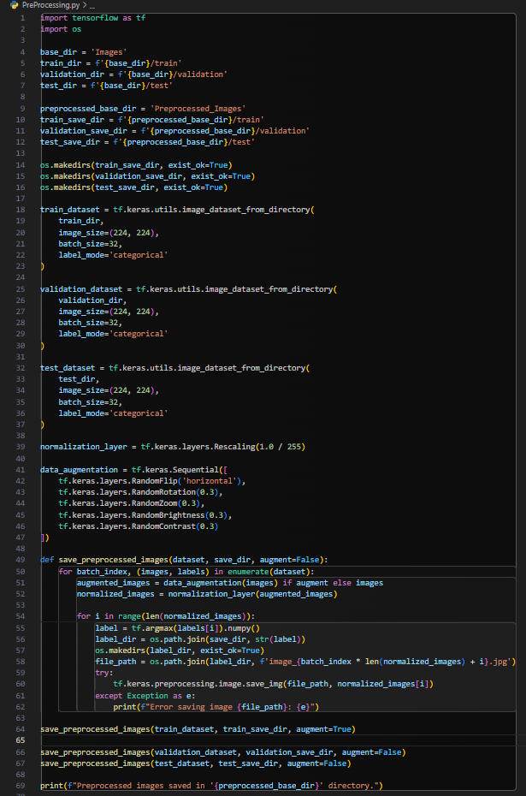

### Steps in this script:

Defining the paths:

* Defines the paths for the train, validation and test directories.
* New directories for saving the pre-processed images gets created (Preprocessed_Images).

Loading the datasets:

* The script uses ‘**image_dataset_from_directory ()’** to load the images from the train, validation and test directories.
* All the images are resized to (224, 224) pixels.
* The script loads the images in batches of 32 to efficiently train the model.

Normalization Layer:

* A rescaling layer gets applied to normalize the pixel values from [0, 255] to [0, 1] by dividing each value by 255.

Data gets Augmented:

* The following augmentation techniques are used to artificially expand the dataset by introducing variations and helps the model generalize better:
* Random Flip
* Random Rotation
* Random Zoom
* Random Brightness
* Random Contrast

Save pre-processed images:

* The augmented images are saved in the “train” folder and the non-augmented images are saved in the “validation” and “test” folders.
* The script iterates through the dataset and saves each pre-processed image using ‘**tf. keras. preprocessing.image.save_img()’.**

# Criterion 2: Handling Complexities and Uncertainties

* **Initial Results:** Initially, the model achieved a low training accuracy of 23%. Despite multiple epochs, the training accuracy gradually increased, but the validation accuracy remained stagnant at around 31%, with an official accuracy of 25% at the end of the initial run. This discrepancy suggested that the model was underfitting, meaning it was unable to learn sufficient features from the data.

**Possible Reasons for Underfitting**:

* **Dataset Size**: The dataset may be too small for a complex model like EfficientNet, which typically requires a large volume of data to generalize well.
* **Data Augmentation**: The data augmentation applied may have been too aggressive, potentially reducing the model’s ability to learn essential features from the images.

* **Challenges and Uncertainties:** Initial underfitting due to a small dataset size and aggressive data augmentation posed a significant challenge, limiting the model’s performance.

## Second Iteration of the Model Training Script:

In the second iteration, adjustments were made to the model training script to improve accuracy and address underfitting. These changes reflect the team’s adaptive approach to managing uncertainties and optimizing model performance.

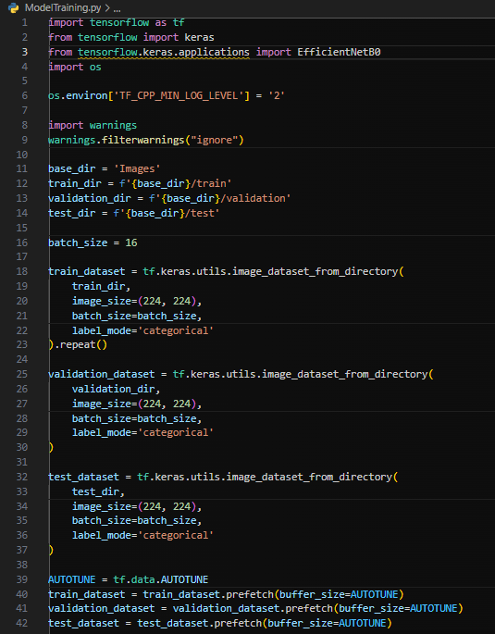

### Different changes:

Here follows the changes we made in our second iteration of the machine learning model:

Data Augmentation changes:

* In the initial model we used the “ImageDataGenerator” to apply various types of augmentation, like shear, zoom and horizontal flipping. This led to more aggressive augmentation.
* In the second iteration we used custom “Keras Sequential” augmentation with RandomFlip, RandomRotation(0.2) and RandomZoom(0.2). This strategy of augmentation is less aggressive.

Loading datasets:

* The second iteration uses “image_dataset_from_directory” from tensorflow to load the datasets instead of the “ImageDataGenerator”. This function creates “tf.data.Dataset” objects directly, which can be augmented, prefetched and mapped with greater control.

Prefetching for performance:

* In the initial version we did not use prefetching.
* In the second iteration we used prefetching so that the CPU can prepare the next batch while the GPU processes the current batch. This sped up the training time.

Batch size changes:

* We changed the batch size from 32 to 16. The reason for this is so the model can be a bit more stable when training.

Model architecture and changes to layers:

* In the second iteration we added an additional Batch Normalization layer before the output layer
* The second iteration still kept it’s dropout rate of 0.5.
* We also added more layers and dropout to increase the complexity.

Fine Tuning:

* In the initial version we fine tuned all of the layers of the base model after the initial training.
* With the second iteration we just fine tuned the last half of the base model layers by unfreezing them.
* This change helped balance the use of pre-trained knowledge with some more specific tuning tailored for our dataset.

Early stopping and learning rate scheduler:

* In the second iteration we reduced the early stopping patience to only 10 epochs to prevent overfitting. This means that the training will stop earlier if the model is not improving.
* We added a learning rate scheduler that reduced the learning rate by multiplying by 0.95 after 10 epochs. This helps improve convergence and slows down the learning rate as the training progresses, which helps the model settle into local minima more effectively.

Steps per epoch calculation:

* In the initial version we used batches based on “ImageDataGenerator”.
* In the second version we defined “steps_per_epoch” and “validation_steps” manually by calculating based on the number of samples and the batch size.
* We tried this approach to ensure that the entire dataset is utilized consistently. This can especially be useful if the dataset is not perfectly divisible by the batch size.

## Results of the 2nd iteration:

The overall accuracy of the second iteration did improve quite a bit with the accuracy standing at 43% now.

Possible reasons for this inaccuracy:

* The model could possibly be overfitting. We can make this assumption because the validation accuracy fluctuated a lot and did not consistently improve.
* The reduced learning rate decrease might have been too aggressive during the fine tuning. This could be preventing the model from making substantial progress.

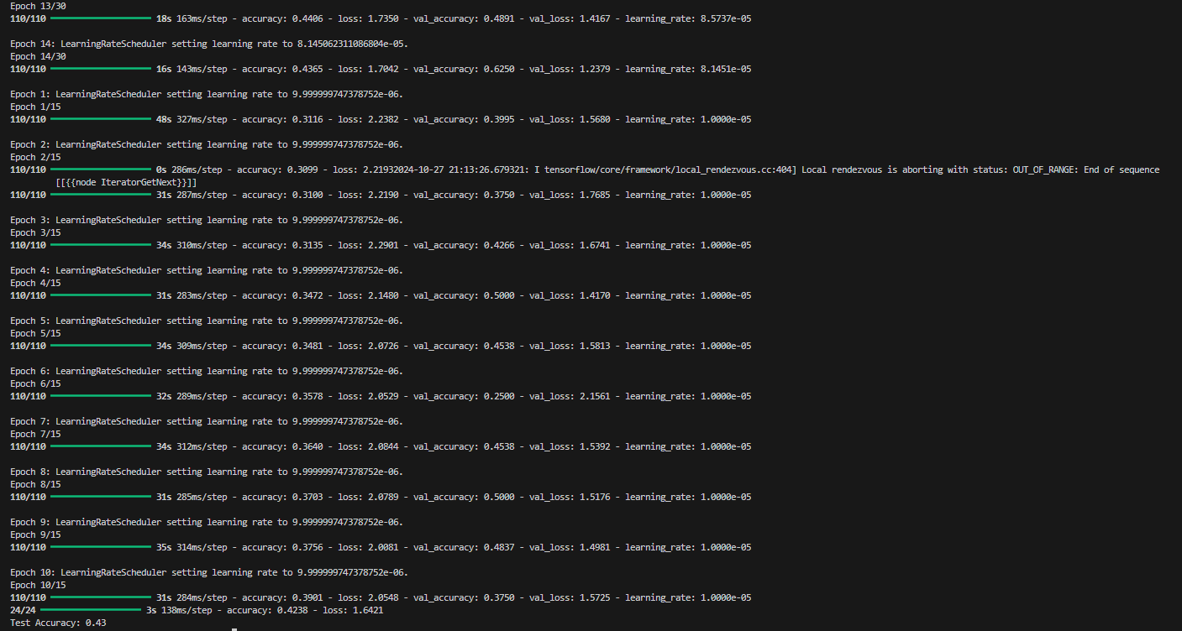

## Third Iteration of the Model Training Script:

In the third iteration, further refinements were made to the model training script. This continued iterative process highlights the team’s commitment to overcoming challenges and improving the model's performance. The third iteration specifically targeted previous limitations and aimed to further stabilize the training process

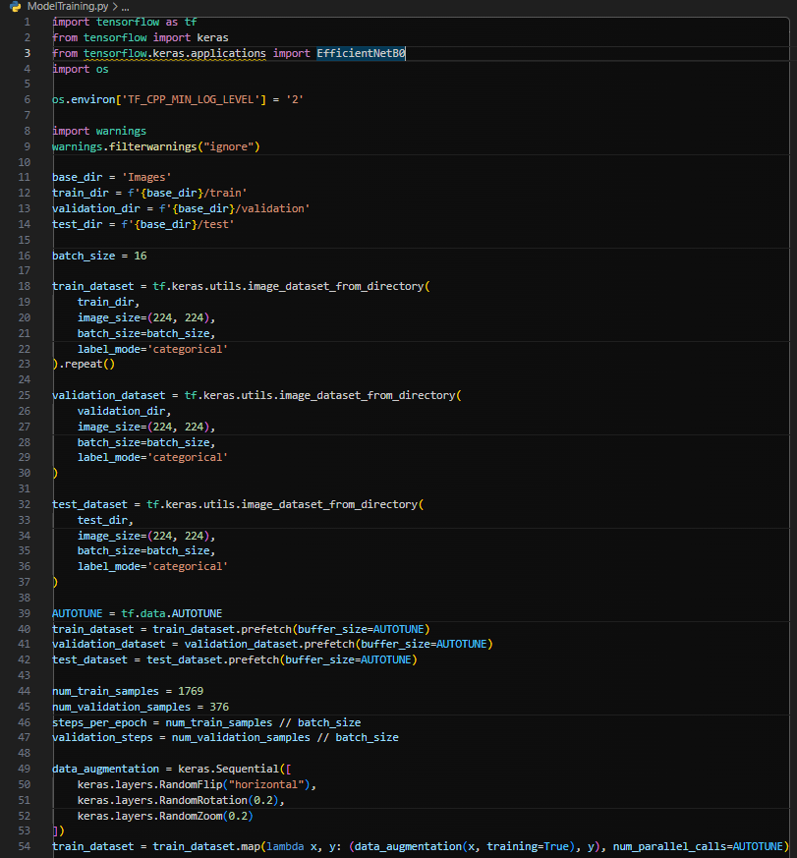

### Different changes:

Learning rate scheduler:

* In the third iteration we completely removed the learning rate scheduler. We did this to make the learning process a bit simpler, because the learning rate decrease in the second iteration might have been too aggressive.

## Results of the 3rd iteration:

After removing the learning rate scheduler the model got an accuracy of 49%. Due to the model only improving with very minimal margins we decided to take a different approach and try to improve the preprocessing script.

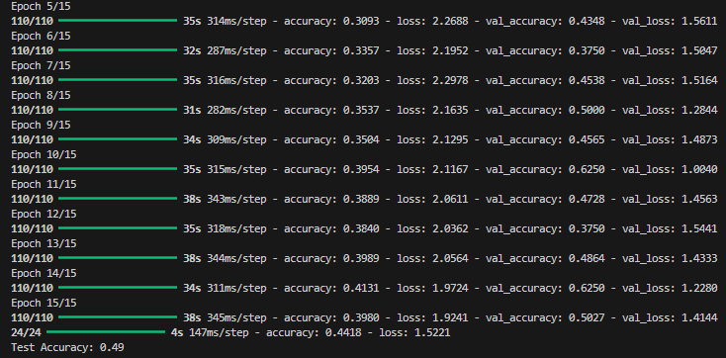

# Fourth Iteration:

## 2nd Iteration of the Preprocessing Script:

In the fourth iteration, the team adjusted the preprocessing script to further enhance model performance. This iteration involved refining augmentation and normalization techniques, dynamically applying augmentation during each training epoch to introduce more variability. These changes aimed to improve training efficiency and boost model accuracy.

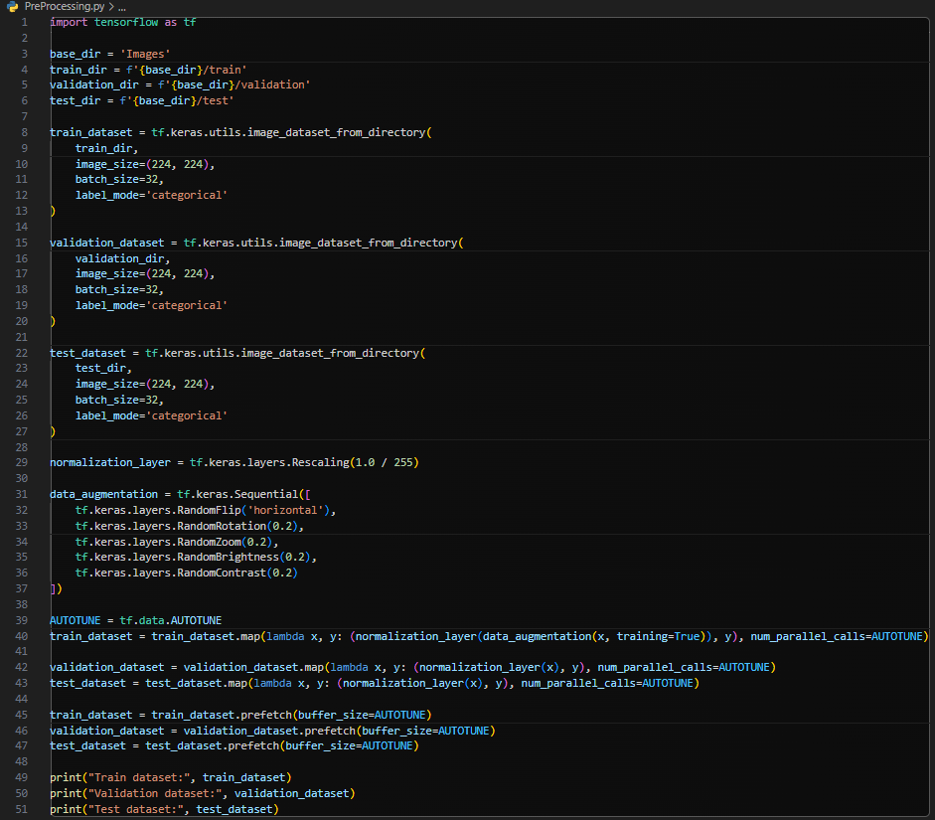

### Different changes:

The saving of the preprocessed images:

* In the second iteration we decided to not save the images to the disk. We added this change to improve efficiency, thereby speeding up the overall workflow.

Applying augmentation and normalization:

* In the initial script data augmentation was only applied when saving the training images, and the images were only normalized after augmentation.
* However in the second script we applied dynamic augmentation and normalization. This augmentation style is model flexible, providing different augmented samples during each training epoch.
* We reduced the augmentation parameters to be less aggressive:
* RandomRotation(0.2)
* RandomZoom(0.2)
* RandomBrightness(0.2)
* RandomContrast(0.2)

Dataset prefetching:

* We added prefetching in the second iteration to improve the training speed, which ultimately enhanced the model’s performance.

### Results of the 4th iteration:

Applying a few changes to the preprocessing script did help improve the model’s accuracy to 56%.

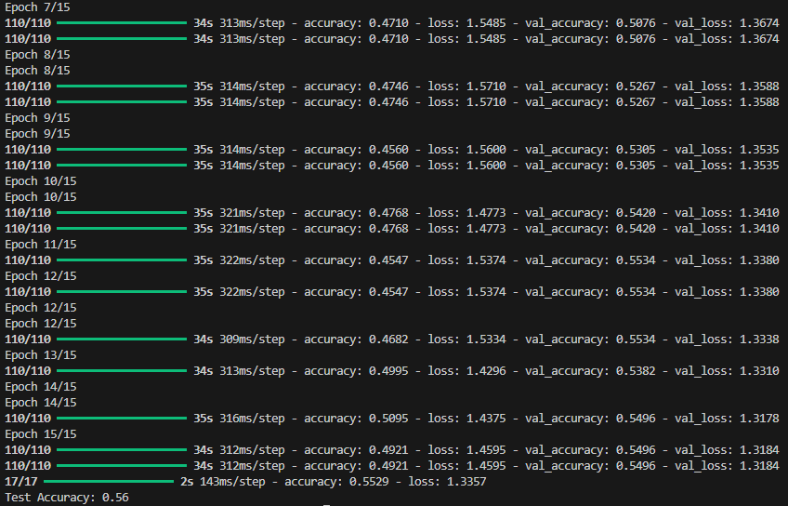

## Final Model Training and Preprocessing Scripts:

After implementing several additional techniques and adjustments, the team reached a model accuracy of 56%. Despite efforts to improve further, this was the highest accuracy achieved with the available data and adjustments. The results from this final model align with the 4th iteration’s findings, demonstrating the team's commitment to refining the model amidst limitations.

## Model training script:

## Preprocessing script:

* **Mitigation Strategies:** The project addressed these complexities by modifying augmentation techniques and fine-tuning specific layers of the EfficientNet model. Adding batch normalization layers and changing batch sizes helped stabilize the training process, tackling overfitting risks.
* **Risk Mitigation and Contingency: Early** stopping and reduced learning rate scheduling were implemented to manage overfitting and improve convergence, especially with an unstable validation accuracy in the second iteration.

# Criterion 3: Application of Specialized Skills

* **Model Training and Evaluation:**

### Initial Model training script:

This script is responsible for creating the actual machine learning model using the pre-processed images. This script also evaluates the performance of the model. Transfer learning was used to leverage pre-trained features from EfficientNet, thereby speeding up and improving the model’s accuracy.

### The libraries we used for this script:

* **tensorflow, keras, EfficientNetB0, ImageDataGenerator:** For building, training and evaluating the model.

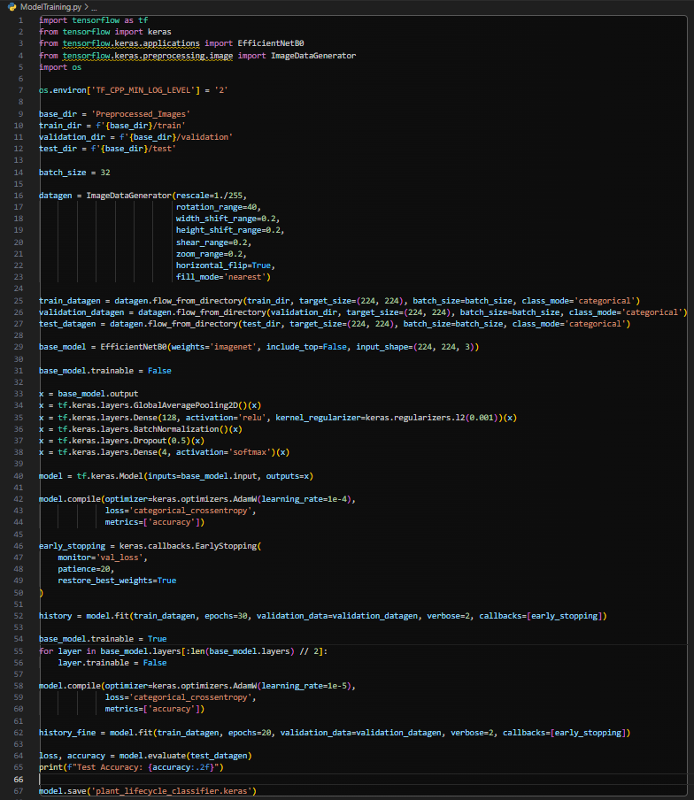

### Steps in this script:

The suppression of the warnings:

* During the installation of Tensorflow and Python something must have went wrong because we keep getting warnings when importing them.
* We wrote code to suppress the warnings to avoid excessive console logs.

Defining the paths:

* This script uses the preprocessed images from the “Preprocessed_Images” folder.

Data generators:

* The script uses ImageDataGenerator to generate batches of image data with real time data augmentation.
* Random transformations like rotation, width/height shift, shear, zoom, etc. are used.

Loading EfficientNetB0:

* A pre-trained EfficientNetB0 model which has been trained on a large dataset (ImageNet) gets loaded. This model helps to quickly build an effective model sine it has already learned useful features.
* The “Include Top = False” part removes the classification layer, so we can add a custom head for our four classes.

Adding custom layers:

* We add a GlobalAveragePooling layer followed by several dense layers with dropout and batch normalization.
* The final layer has four output nodes with softmax activation to output probabilities for each of the four classes.

Compile the model:

* The script uses the AdamW optimizer with a learning rate of 1e-4.
* The loss function is categorical crossentropy, which is suitable for multi-class classification problems.

Early stopping callback:

* This callback stops training if the validation loss stops improving fro 20 epochs, preventing overfitting.

Training the model:

* The model gets trained for a total of 30 epochs using “train_datagen” and evaluates it using “validation_datagen”.

Fine-tuning the model:

* This unfreezes the base model layers, making them trainable.
* The model gets compiles with a lower learning rate (1e-5) to adjust the features learned by the EfficientNet base.
* The model gets fine-tuned for an additional 20 epochs.

Evaluating the model:

* The model gets evaluated on the test dataset and the accuracy gets printed.

Saving the model:

* The model gets saved to the “plant_lifecycle_classifier.keras” file.
* **Specialized Skills and Tools:** The team applied skills in TensorFlow, Keras, and transfer learning techniques with EfficientNetB0. Tools like `*ImageDataGenerator*` and TensorFlow’s `*image_dataset_from_directory*` helped manage real-time data augmentation.
* **Application of Skills to Project:** The team’s iterative adjustments in model training scripts demonstrate a proactive approach to problem-solving. Fine-tuning techniques and custom augmentation were particularly effective.
* **Innovation and Effectiveness:** Customizing the augmentation techniques and leveraging prefetching to optimize CPU/GPU coordination are innovative, optimizing the model’s performance within data limitations.

# Criterion 4: Ethical Considerations

* **Ethical Implications**: Potential ethical implications include responsible use of plant images and adherence to data privacy standards.
* **Ensuring Ethical Conduct:** Ensuring that all data usage complies with relevant privacy and copyright laws, especially if the images are sourced from external platforms, is essential.
* **Cultural Diversity and Social Impact:** Acknowledging the socio-environmental impact of plant monitoring, this project supports broader environmental awareness.

# Criterion 5: Information Presentation and Communication

* **Effective Communication:** The team organized documentation and detailed steps for each phase of the project, which is essential for clear communication with stakeholders.
* **Audience Tailoring:** Clear language was used in documentation to explain complex concepts, which aids stakeholders’ understanding regardless of technical knowledge.

# Criterion 6: Understanding of System Interactions

* **System Interactions:** The project’s neural network model interacts with cloud-masked Landsat imagery, TensorFlow data augmentation libraries, and custom data loaders.
* **Dependencies and Interdependencies:** Proper handling of dependencies, such as TensorFlow libraries and EfficientNet model integration, was crucial for successful training.
* **Managing Interactions:** Dataset prefetching and the `image_dataset_from_directory` method enabled smoother handling of large data flows, ensuring consistent performance.
* **Data Handling and Organization**: The download and organizing script establishes the structure for data processing by creating directories and managing file paths. The use of os for directory management and *tqdm* for progress tracking supports seamless data organization and interaction with other systems. This organization enables efficient access and integration of data into subsequent processing and model training scripts.

# Criterion 7: Accountability and Responsibility

* **Roles and Responsibilities:**
* **Time Leader:**
* **Time Management and Resource Allocation:** The team’s structured approach to iterations suggests strong time management, optimizing resources by reusing pre-trained models and gradually adjusting model parameters to achieve higher accuracy.
* **Issue Resolution:** Problems such as overfitting and underfitting were promptly addressed through systematic testing and modifications across each iteration.

# UI Design:

### Home page:



### Project Charter:

This is a simple page to sums up what we had to do for the project

### Aim:

### Project Suite:

### Objectives:

### Stakeholders:

### Image processing:

### Server startup:

We start with all buttons disabled as the user will first need to start the server before the image processing can happen

As the server starts up we disable the home button to prevent interruptions and give text feedback to the user to know what to wait for before continueing

### Image upload:

After the image is uploaded the user can Process the image this will send a command through the server that we started to send the image data to the model that we trained and give us a class and a confidency level A close-up of a plant

### Image processing:

After the image is uploaded the server will respond and the results are uploaded to the UI via the server

